**Lab 6 Report: Edge Detection in Images: UPC Decoding**

**Kenneth Beartusk**

**3 Lab: FIR Filtering of Images**

3.1 Finding Edges: 1-D Filter Cascaded with a Nonlinear Operators

3.1.1 Edge Detection and Location via 1-D Filters

1. See MATLAB code.

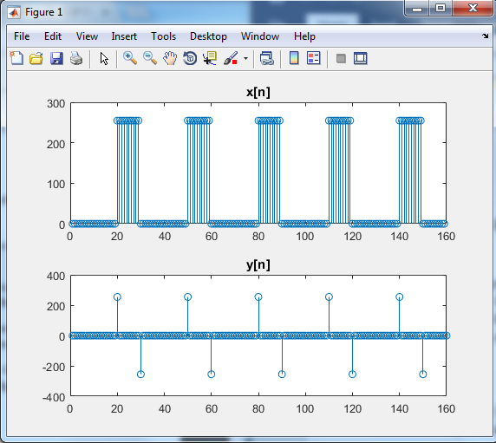

1. y[n] = $\sum_{k=0}^{∞}{δ\left[n-30k-20\right]- δ}\left[n-30k-30\right]$
2. size(y[n]) = size(b[n]) + size(x[n]) – 1
3. See MATLAB code.
4. See MATLAB code.

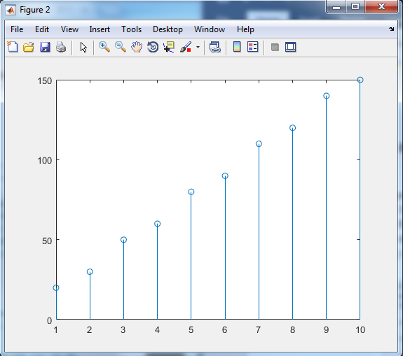

3.2 Bar Code Detection and Decoding

3.2.1 Decode the UPC from a Scanned Image

1. See MATLAB code.
2. See MATLAB code.

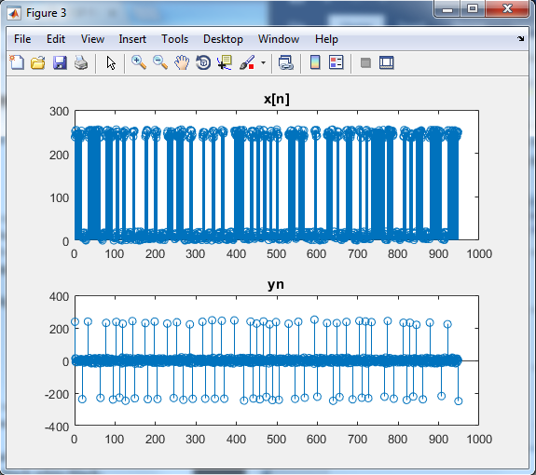

1. See MATLAB code.

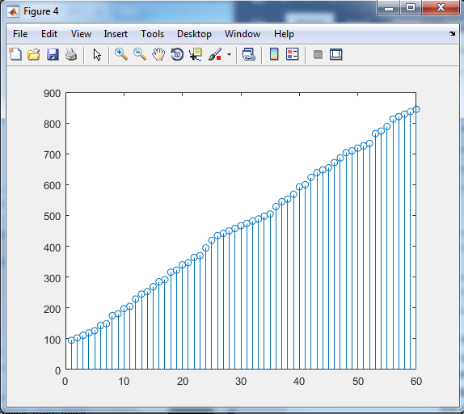

1. The plot of delta[n] does not vary between 1 and 4 as one might think. The plot varies between 6 and 32. And not only that, but there are not 4 different integers in specific that it’s varying between. It may be reasonable to think that the plot would vary between the values of [6,14,24,32] but this is not the case. The reason is due to the inexactness of the image and maybe also the inexactness of the printed bar code. But, mostly probably the inexactness of the image due to aliasing from how many pixels the image can be shown in.

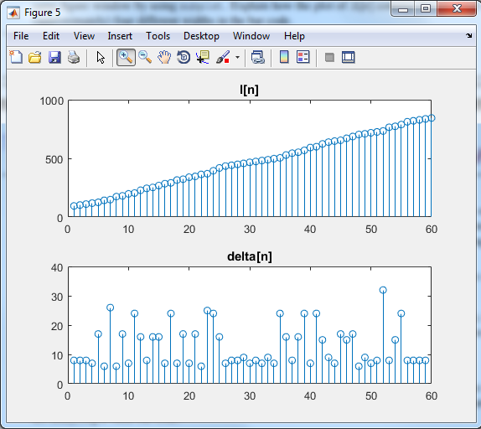

The reason this does correspond to the 4 different widths idea, is because the values shown on the plot line are somewhat grouped together into groups based on their lesser amount of variance between each other.

For instance, [10,11,13,45,48,43] is a set of values. These values could be grouped into 2 separate groups due their variance. [10,11,13] would be one group and [45,48,43] would be another group.

1. Since each number in the UPC code consists of a total of 7 widths. The code should consist of about 7x12 widths, which is equal to 84 widths. But, there also 3 widths on each edge of the code as well as 5 widths in the middle. Total_widths = 84 + 6 +5 = 95.
2. For theta1 I used as the total amount of pixels across. I had to take into account the fact that UPC code is not as many pixels wide as the entire image. There are 5 edge locations that are not part of the actual UPC code. So I didn’t start counting pixels until after these 5 edges and ended before the total amount of edges minus 5. So, L = 837 – 95 = 742 and $L=95∅_{1}$. Therefore,
$$∅_{1}= \frac{742}{95}=7.81$$

3. See MATLAB code.
4. See MATLAB code.
5. See MATLAB code.
6. No matter what I did with this part I was not able to get a correct UPC code reading. I think it was due to the image being aliased in general.